**Data Analyst in Power BI Data-Camp 2025**

**Section 5: Data Preparation**

1. **Profiling your Data and Introduction to Power Query**

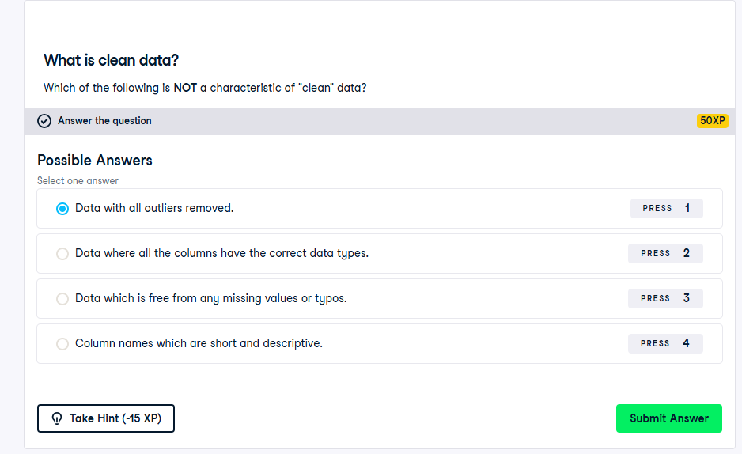

[**Shape the initial data - Training | Microsoft Learn**](https://learn.microsoft.com/en-us/training/modules/clean-data-power-bi/2-shape-data)

**Exercise 1.1**

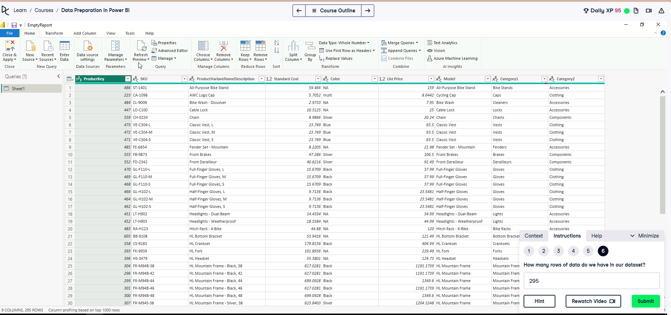

**Exercise 1.2**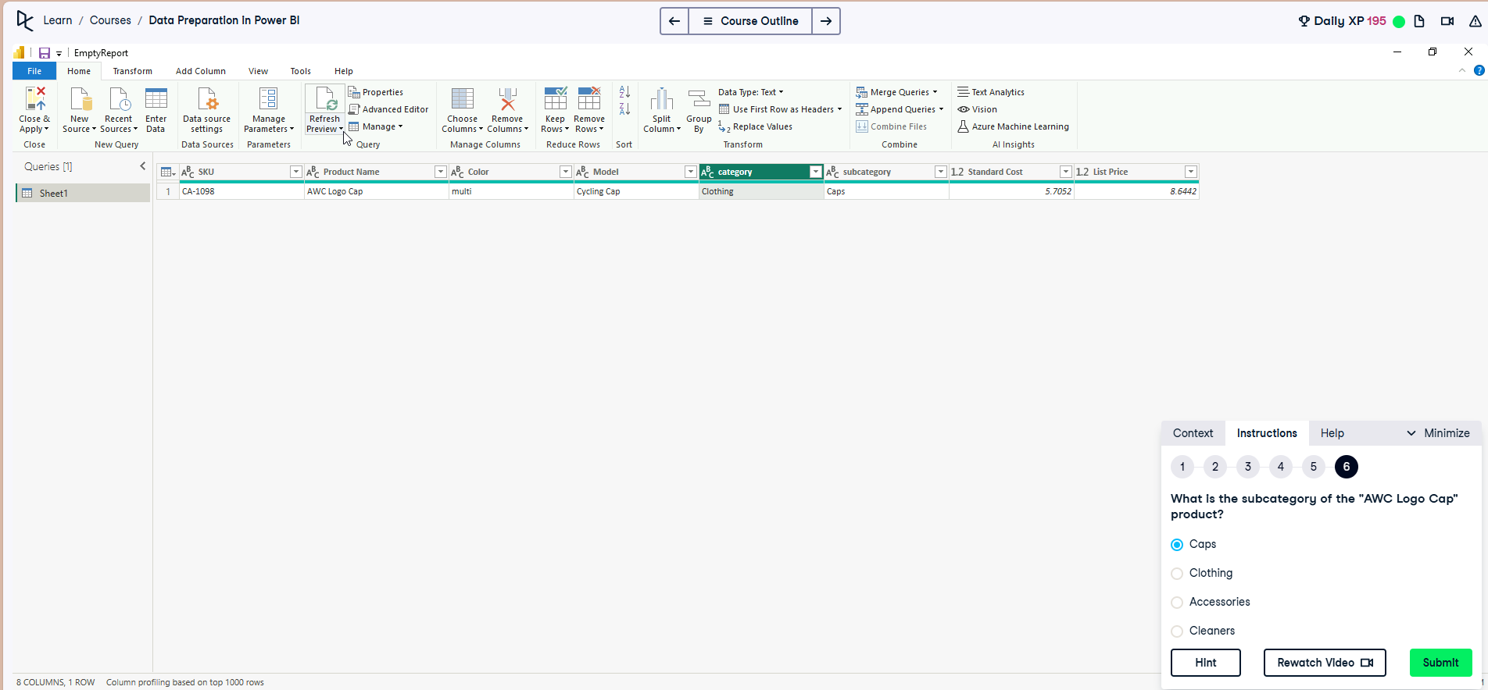

**Exercise 1.3**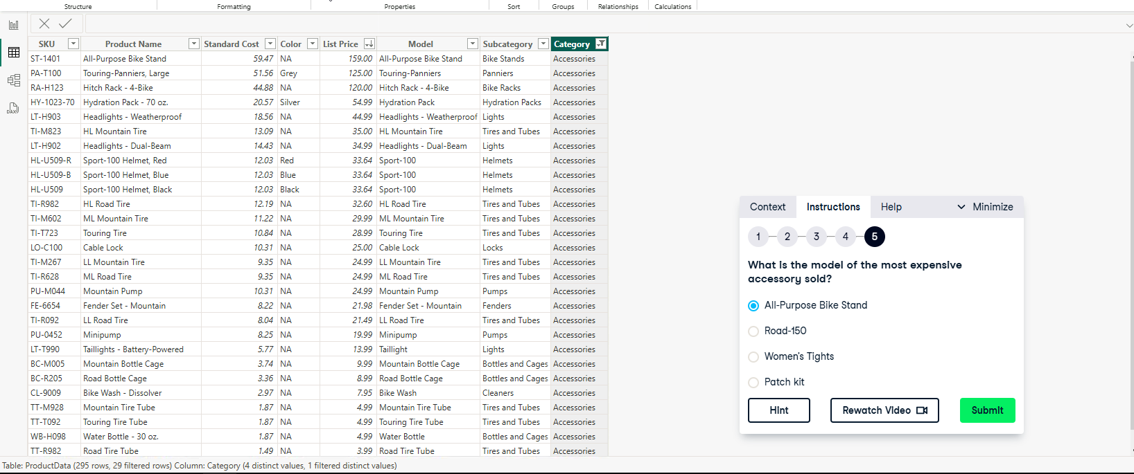

**2. Data Preview features in Power Query**

**Exercise 2.1**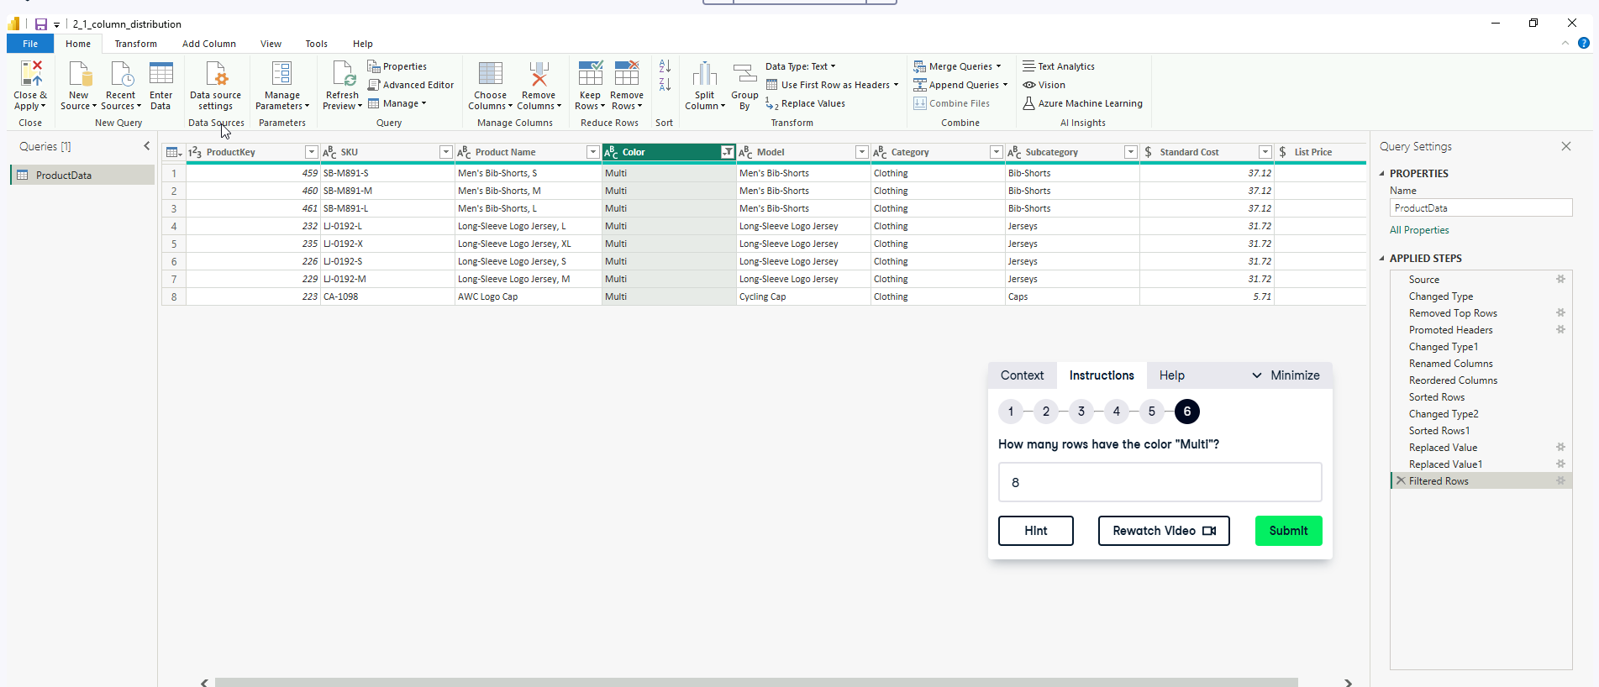

**Exercise 2.2**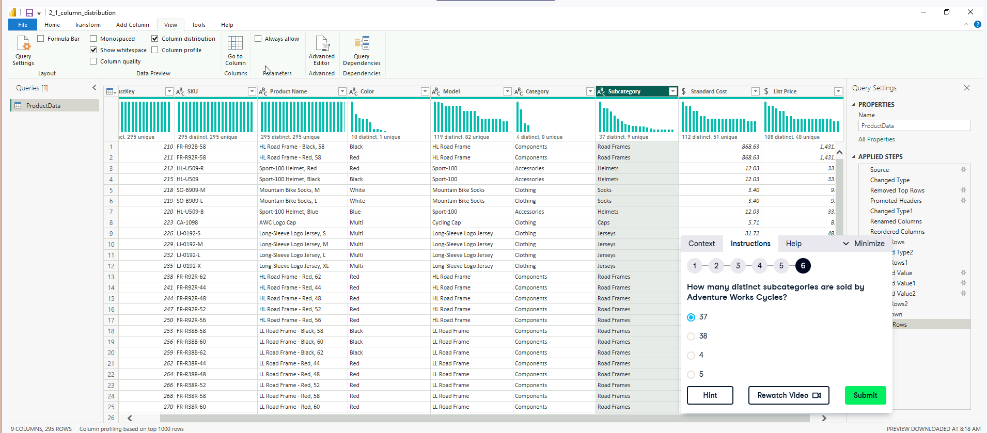

**Exercise 2.3**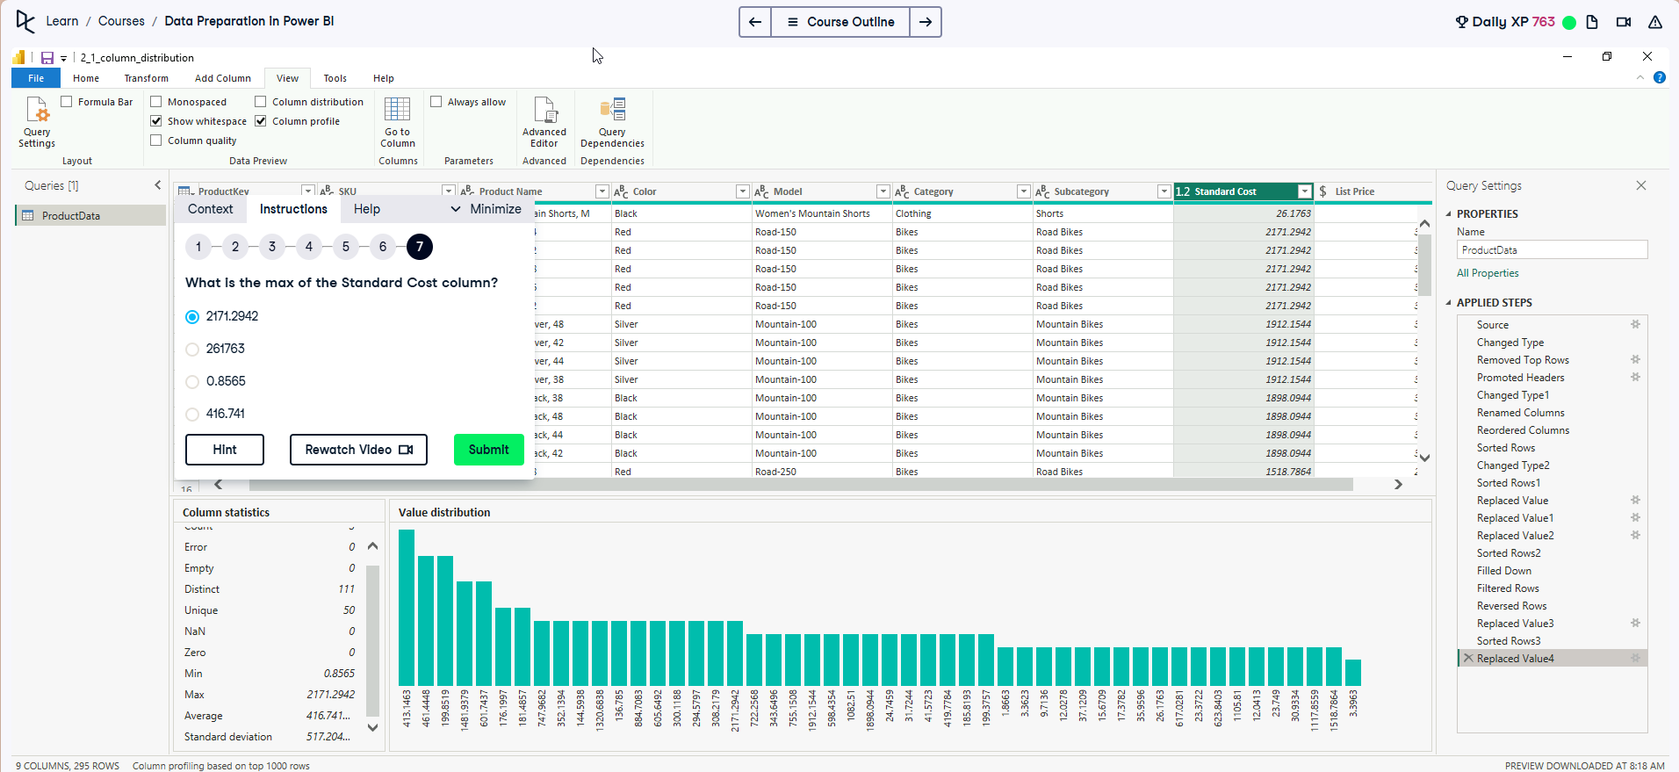

**Exercise 2.4**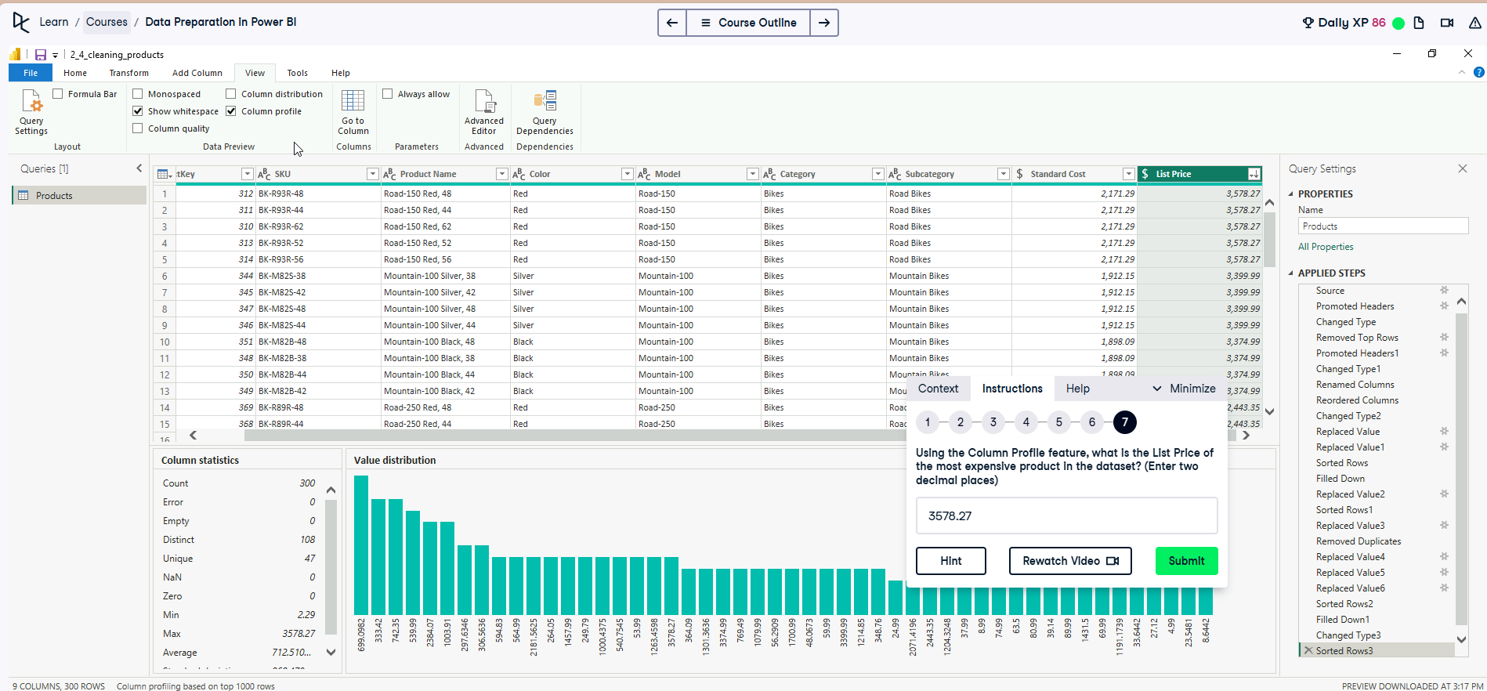

**3. Data Manipulation**

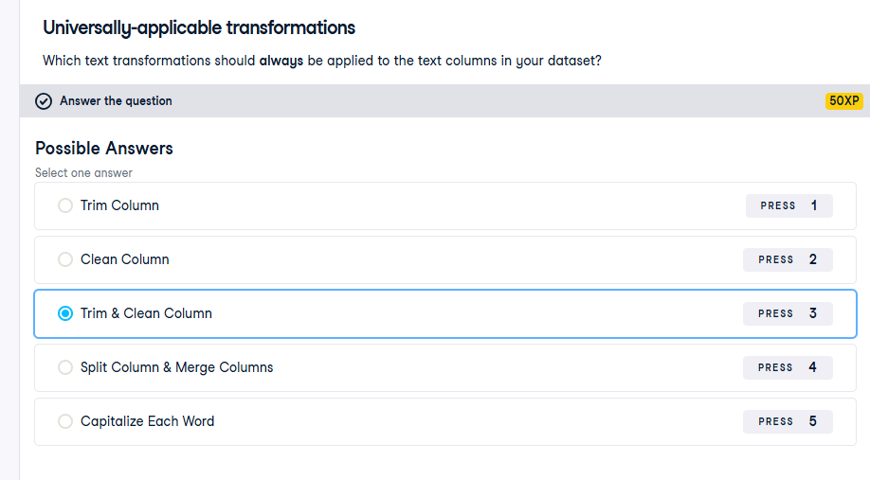

**Exercise 3.1**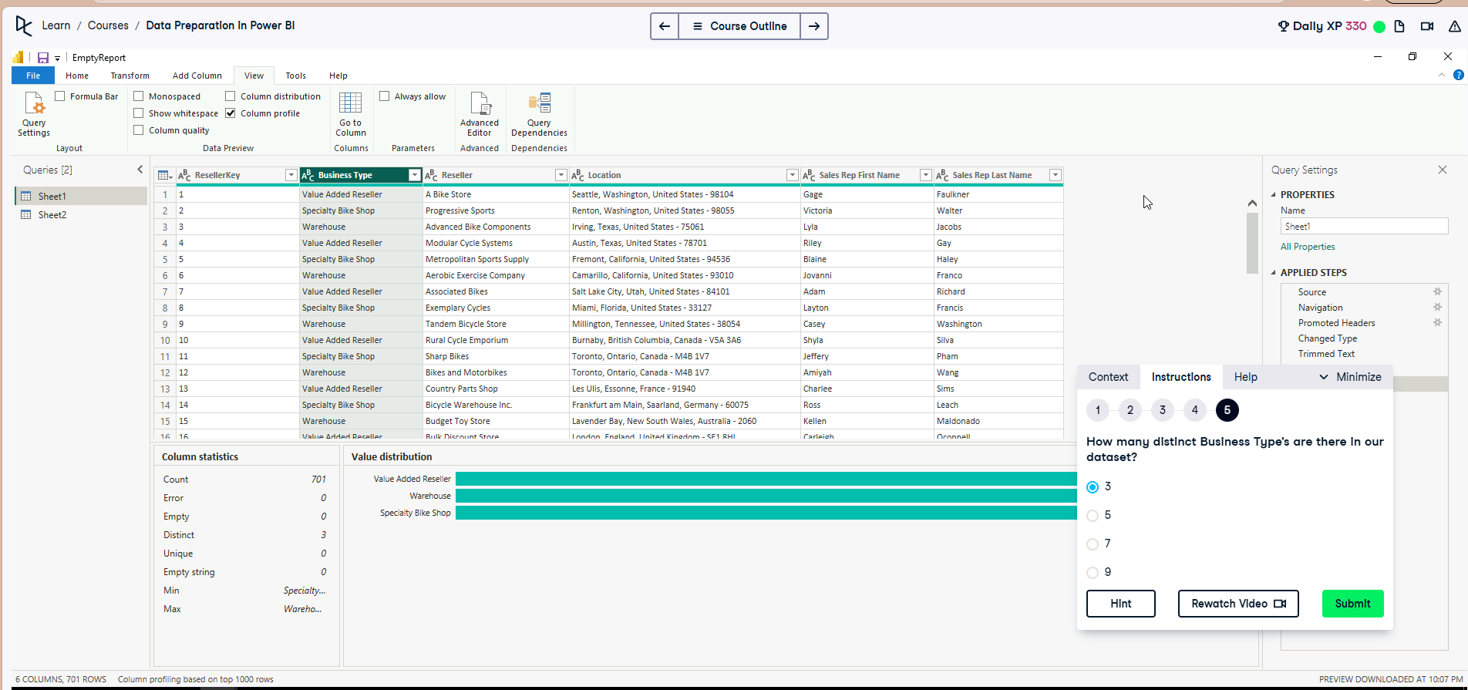

**Exercise 3.2**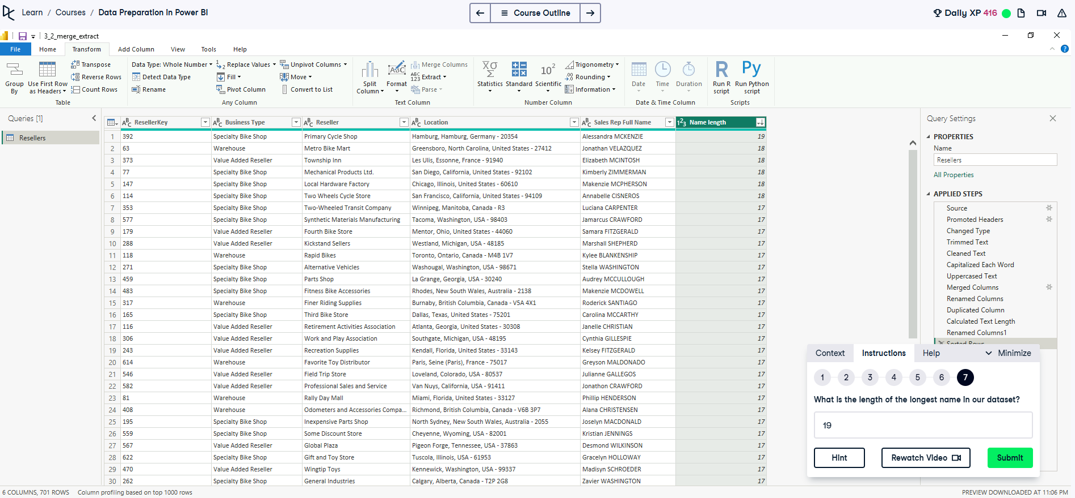

**4. Numerical transformations in Power Query.**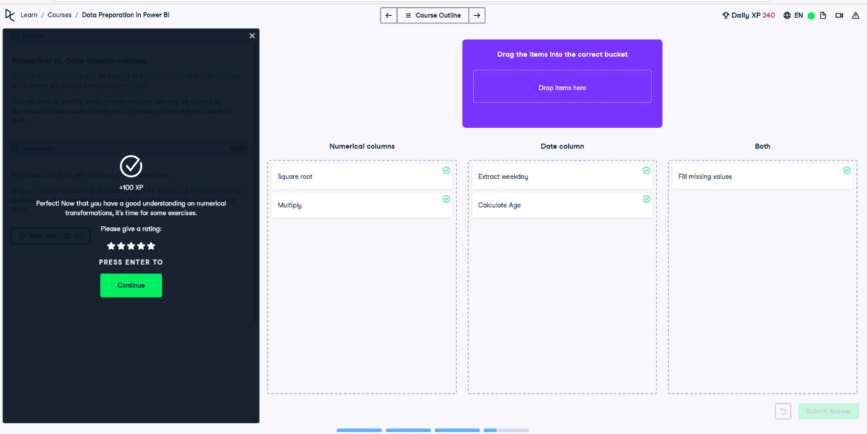

**Exercise 4.1**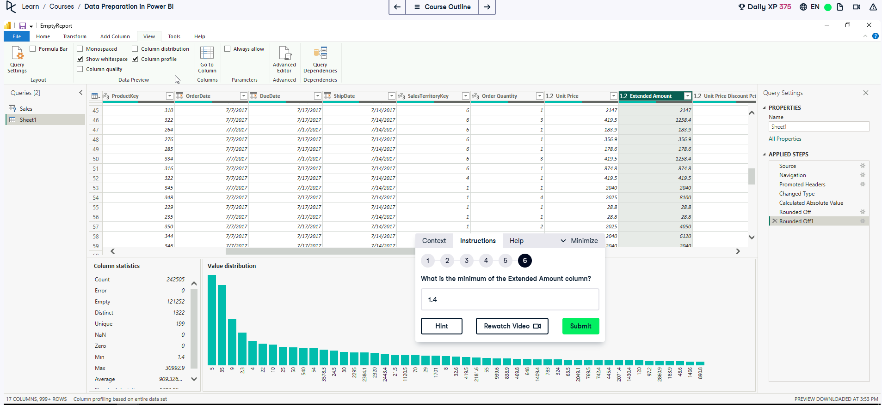

**Exercise 4.2**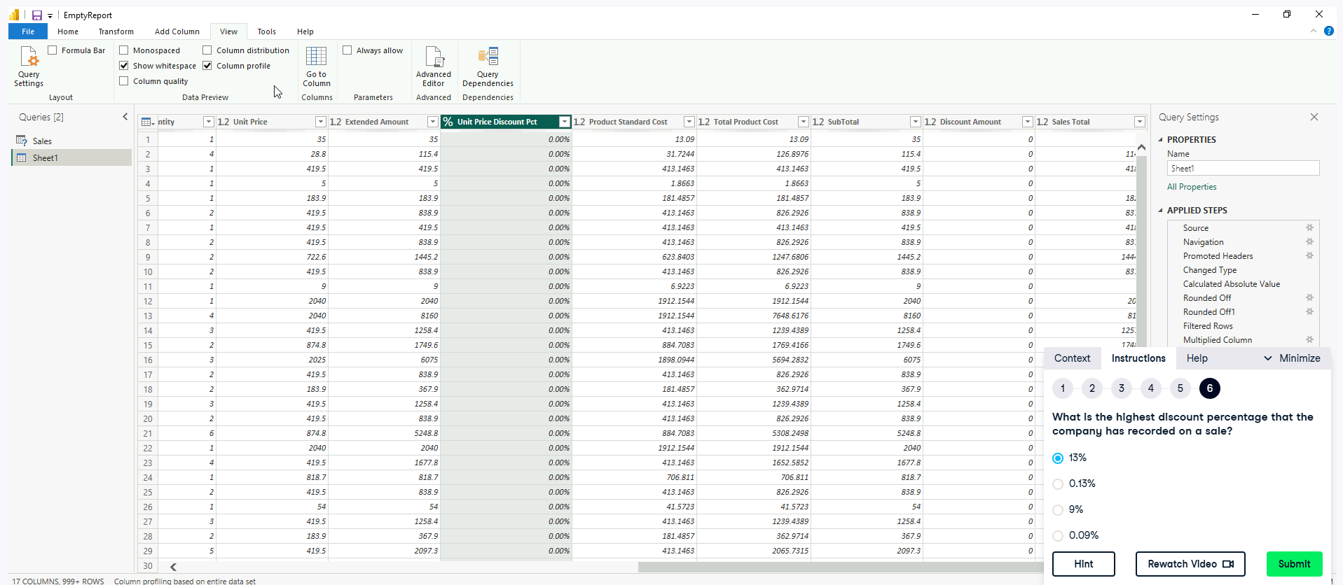

**Exercise 4.3**

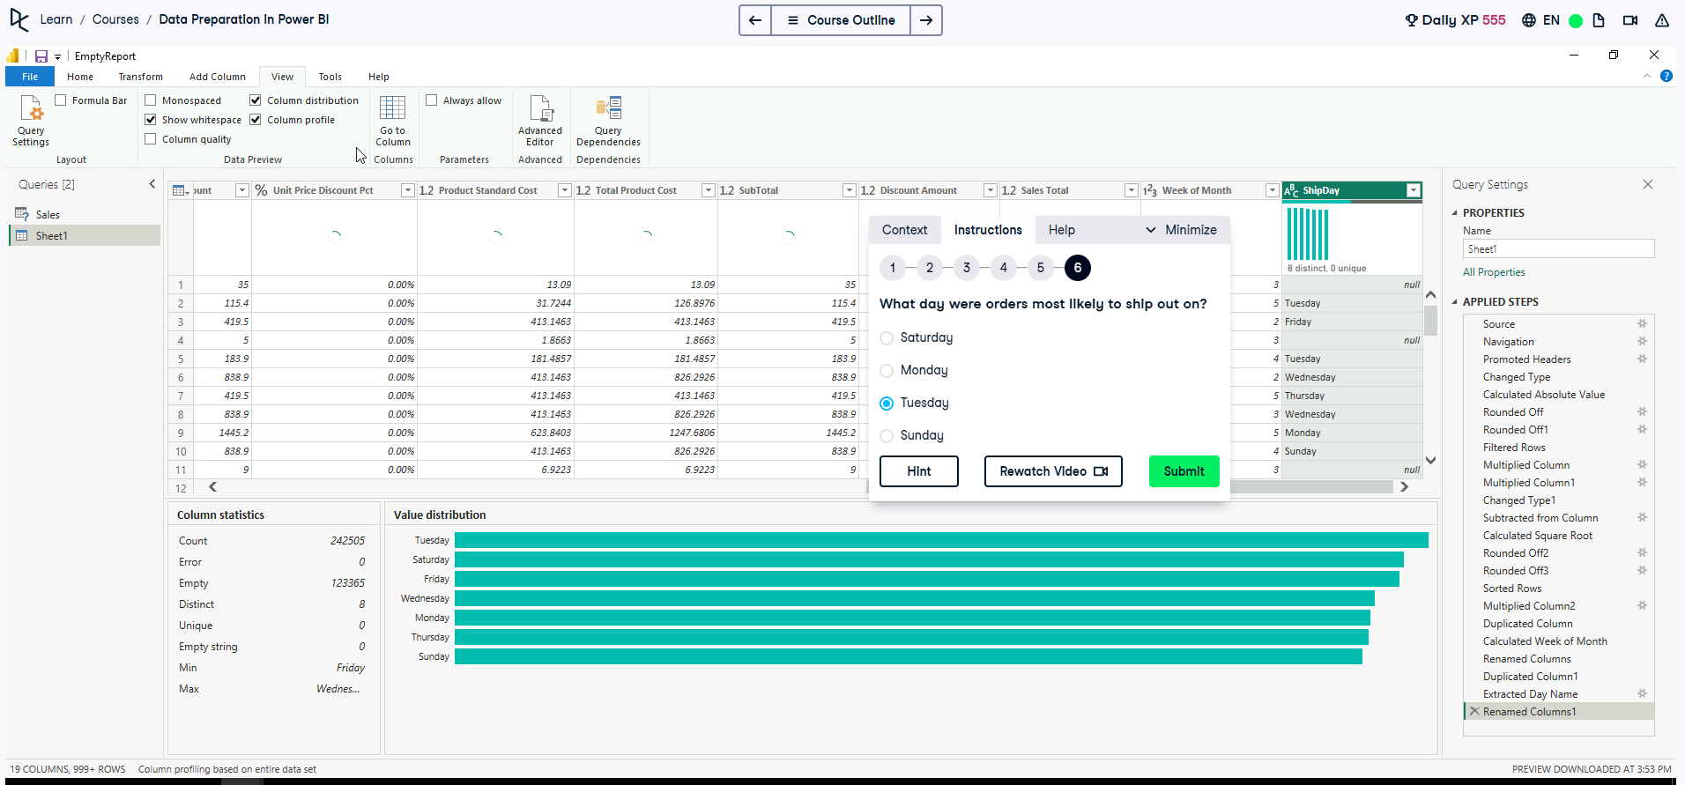

NOTE: IF VIRTUAL MACHINE LOADING SCREENS TAKE SOME TIME, RESET YOUR DESKTOP OR VM. Might have to redo the exercises again.